TITTLE PAGE

Project Title: The Grade Calculator
Course: Python Essentials
Submitted by: Ankita
Registration no.: 25BMR10022
Department: Mech.(AI&Robotics)
Submitted to: VITyarthi
College: VIT BHOPAL UNIVERSITY
Academic year: 2025

1.PROJECT OBJECTIVE: -
The primary objective the weighted grade calculator project is to demonstrate the practical application of core python programming concepts to solve a common, real-world academic problem.

The key goal is to create a tool that accurately performs the weighted average formula for the fixed assessment categories (like – homework, midterm exams, final exams).

2.SCOPE AND REQUIREMENTS: -

The scope of this project is that this application is built using a single python script.

~ FUNCTIONAL REQUIREMENTS: -
a) Input Acquisition – The system must prompt and collect numeric values for weights and scores of the three components.
b) Input Validation – The system must verify that all collected inputs are valid floating-point numbers and within the 0 to 100 range.
c) Weighted Calculation – The core logic must calculate the final percentage grade using the weighted sum of scores.
d) Grade Mapping – The system must implement the logic to assign a final letter grade (A, B, C, D, E) based on standard percentage cutoffs.

~ NON-FUNCTIONAL REQUIREMENTS: -
a) Reliability – The program must be fault-tolerant against invalid data types (e.g., text instead of numbers) using exception handling.
b) Usability – The command-line interface must be intuitive, providing clear prompts and a structured final output summary.
c) Accuracy – All arithmetic must utilize floating-point numbers (float) to ensure precision in the final percentage result.
d) Maintainability – The code must be well-commented and modular, separating the logic into functions to facilitate future updates.

3.TECHNICAL EXPECTATIONS: -

The project required a deep understanding and implementation of the following concepts:

A) Data Type Conversion: Converting the input string from the user into a numeric float to enable calculations.

B) Modular Programming: Defining reusable functions (get_weight_input, get_score_input) to handle repetitive input and validation tasks.

C) Error Handling: Using the (try...except ValueError) block to manage exceptions gracefully, thereby meeting the Reliability requirement.

4. SYSTEM ARCHITECTURAL DESIGN: -

This project follows a Linear Procedural Architecture based on the flow of execution in the Python script.

~ Components:

a) Input/Validation Module: Handled by the helper functions, which are responsible for all user interaction and ensuring data quality.

b) Processing Module: The section of the main script that performs the arithmetic calculation for the weighted average.

c) Logic Module: The (if-elif-else) block that determines the letter grade based on fixed academic thresholds.

d) Output Module: The final print() statements that format and display the results to the user.

~ code used and output:
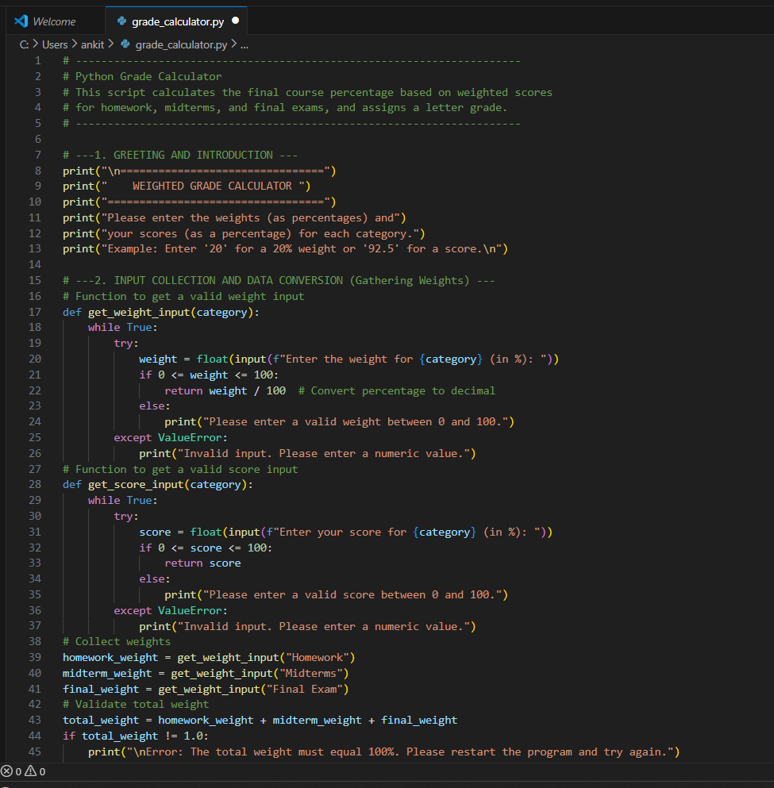
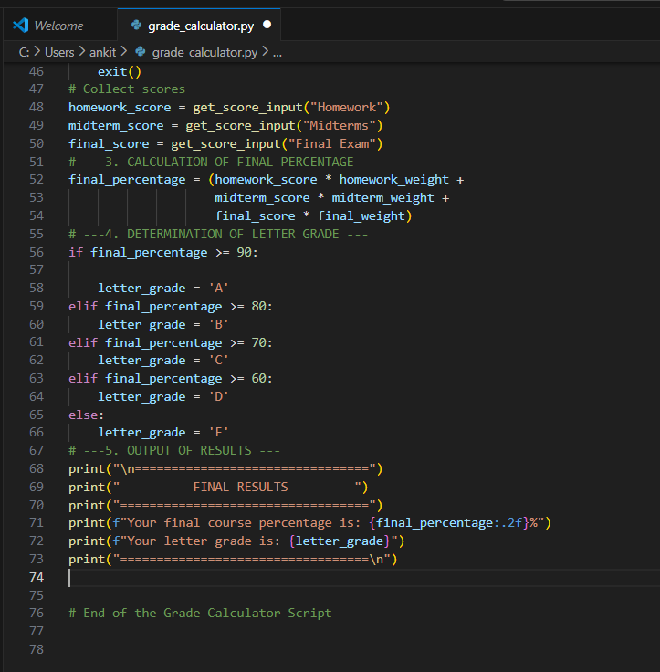

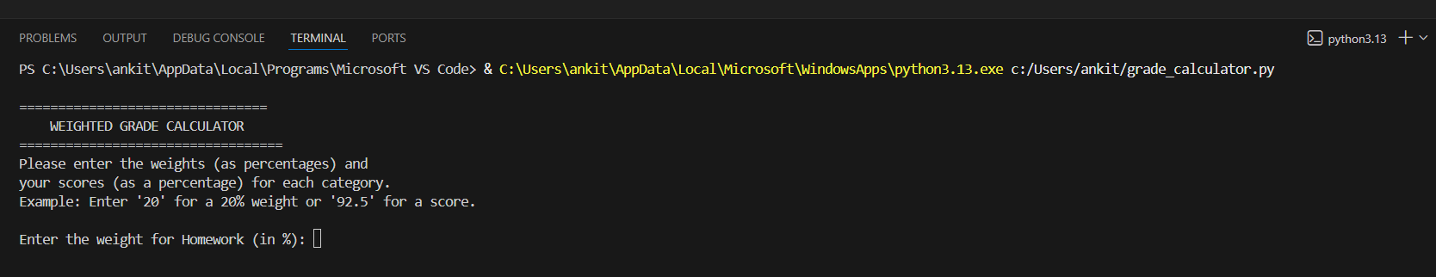
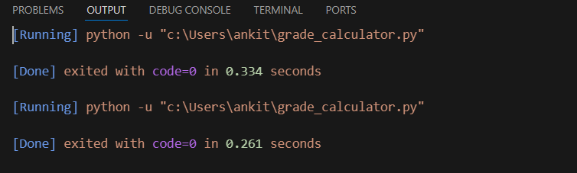
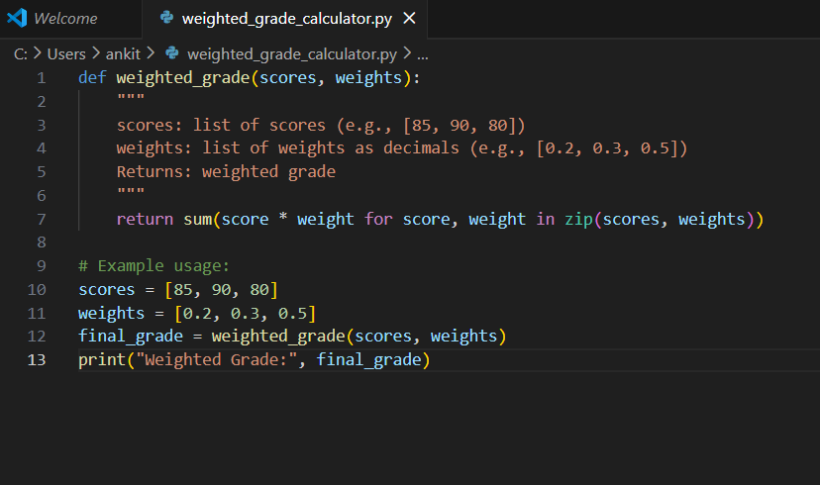
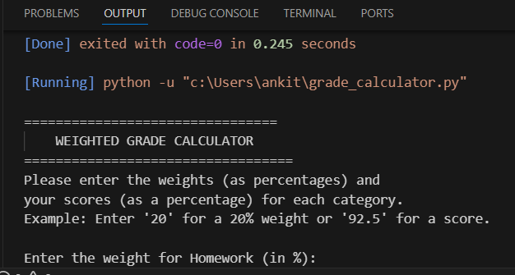
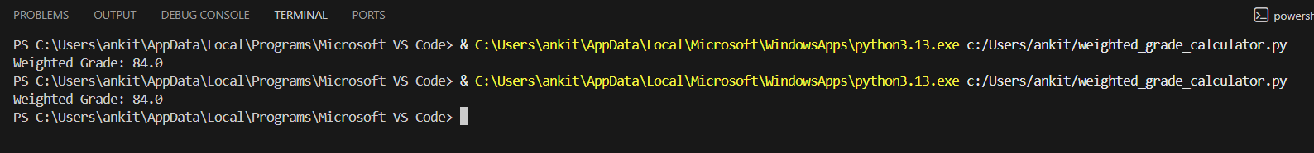
5. DESIGN AND DOCUMENTATION REQUIREMENTS: -

a) Design Decisions:
~ Function Encapsulation: Input logic was isolated in functions to enforce Modularity. This allows the core calculation section to remain clean and focused solely on mathematics.

~ Embedded [try/except]: Wrapping the float(input(...)) command in a try/except block and placing it inside a while loop was chosen to ensure the program cannot crash and will force the user to provide valid input, directly addressing Reliability.

~ Immediate Weight Conversion: Weights are converted from percentage (e.g., 20) to decimal (0.20) immediately upon input. This simplifies the final calculation formula, making it cleaner and less error-prone.
b) Documentation Requirements:
~ Code Comments: Extensive in-line comments explaining the purpose of variables, the logic of the functions, and the mathematics used in the calculation.

~ [README.md] and [statement.md]: Repository files providing a summary, features, and run instructions for the project.

~ Project Report: This detailed document, which covers all stages of the software development life cycle for this project.

6. IMPLEMENTATION DETAILS:
~ Core Calculation and Grade Mapping:
The final percentage is calculated by summing the weighted contributions:
Final % = (score*weight) of homework + (score*weight) of midterm exams + (score*weight) of final exams and so on.
The assignment of the letter grade is handled using an if-elif-else conditional structure, which efficiently checks the grade boundaries.

~ Workflow Diagram:
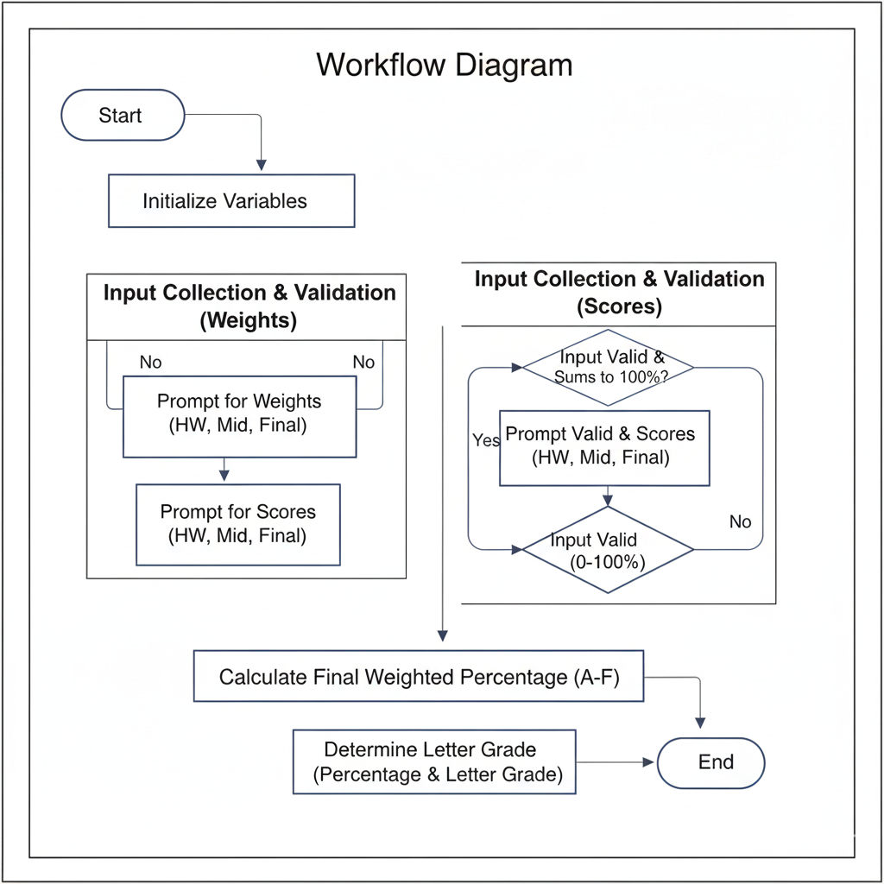

~ Use case Diagram:
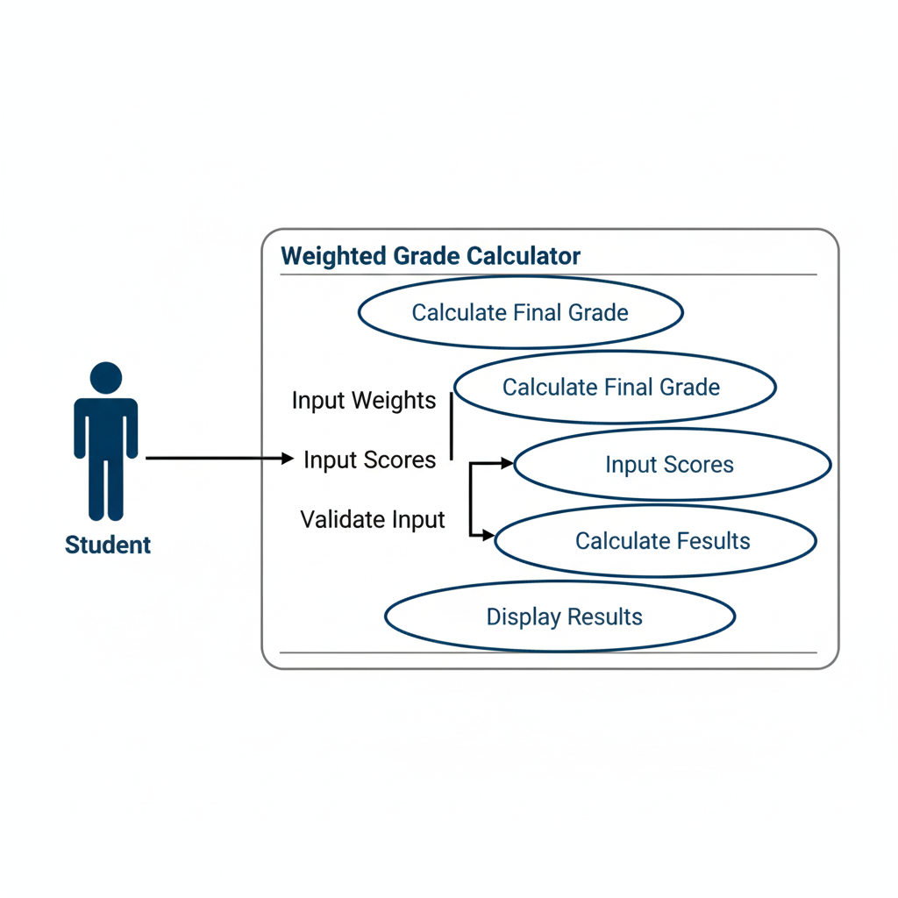
7. TESTING APPROACH:
Testing was done by focusing on the external behaviour of the system. The testing concentrated on verifying the logic at critical boundaries and validating the robustness of the input functions.

~ Test Cases:
- Boundary digits test
- Non-numeric error
- Zero/hundred test

8. CHALLENGES FACED:

The primary technical challenge encountered was ensuring Reliability of the user input mechanism. Initially, any input that wasn't a number caused the program to crash due to a ValueError. This was overcome by refactoring the input code to use the try-except block, transforming a potential point of failure into a controlled user experience loop.

9. LEARNINGS AND TAKEAWAYS:
The development of this project reinforced several critical programming concepts:

~ Exception Handling: Gained essential experience using try and except to create resilient, user-friendly applications.

~ Modular Design: Understood the benefit of breaking down a script into dedicated, reusable functions to improve code readability and maintainability.

~ Data Integrity: Solidified the necessity of data type conversion (float()) and input validation before any critical calculation.

10. FUTURE ENHANCEMENTS:
a) Dynamic Category Support: Refactor the program to use a list or dictionary to allow the user to define any number of categories and their corresponding weights/scores, instead of being limited.

b) Grade Threshold Customization: Allow the user to define their own letter grade cutoffs (e.g., set an 'A' at 93% instead of 90%).

11. REFERENCES:
a) Python 3 Official Documentation: Used for consulting best practices for basic I/O and exception handling.

b) Python Essentials by VITyarthi : Source for the foundational concepts of functional decomposition and conditional statements.

c) Weighted Average Formula: Basic principles of arithmetic used for the core calculation logic.

